Interval training best for weight loss, study review concludes
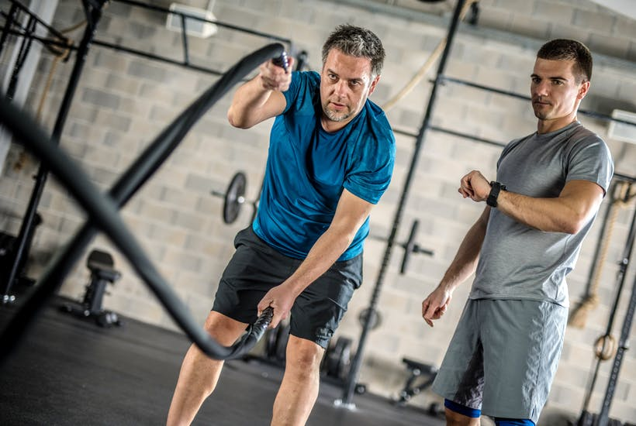
19th February 2019
Interval training may shed more pounds than a continuous moderate intensity workout, according to a new pooled analysis of the available evidence, which has been published in the British Journal of Sports Medicine.
Sprint interval training may be most effective for weight loss, the analysis indicates, although the breadth of training programmes studied makes it difficult to recommend one particular approach over another, the researchers say.
Most physical activity guidelines recommend a high volume of exercise for weight loss, equivalent to an hour or more every day. But few people carve out the time needed to meet this recommendation.
The researchers wanted to find out if interval training might match a continuous moderate intensity workout for overall weight loss (total absolute fat mass) and reductions in percentage body fat-the percentage of fat that makes up body weight, despite taking less time to do.
Interval training describes intermittent intense effort, interspersed with recovery periods. The two most common types are high intensity interval training, or HIIT for short, which includes various exercises; and sprint interval training, which includes running, jogging, speed walking, and cycling.
They searched research databases for relevant studies that directly or indirectly compared interval training with continuous moderate intensity exercise over a period of at least four weeks.
The data from 41 studies involving 1115 people were combined for thematic analysis and the results data from 36 studies involving 1012 people were pooled.
Both interval training and a continuous workout reduced overall weight and percentage body fat, irrespective of starting weight or gender, the findings showed. But while there was no significant difference in percentage body fat reduction between the two approaches, there was a significant difference in the amount of weight lost, with interval training proving the more effective method. Interval training provided a 28.5 per cent greater reduction in weight, overall.
Further analysis, comparing sprint interval training with a continuous moderate intensity workout, revealed an even larger difference in weight loss.
‘It is important to be aware of the possible risks and caveats associated with higher intensity training,’ the researchers point out. ‘For example, it might increase the risk of injury and impose higher cardiovascular stress. Adherence should also be examined as higher intensity protocols can result in higher discomfort.’

