Vatican’s Secret Rules for Catholic Priests Who Have Children
Image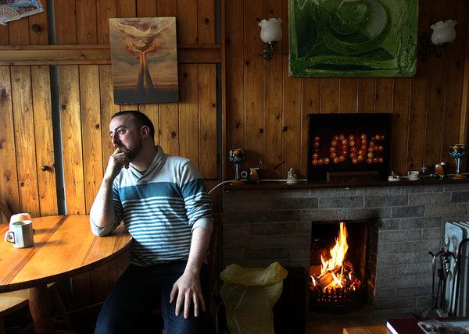
“It’s the next scandal,” said Vincent Doyle, the son of a priest. “There are kids everywhere.”CreditCreditSuzanne Kreiter/Boston Globe, via Getty Images
By Jason Horowitz and Elisabetta Povoledo
- Feb. 18, 2019

•
•
• • • ROME — Vincent Doyle, a psychotherapist in Ireland, was 28 when he learned from his mother that the Roman Catholic priest he had always known as his godfather was in truth his biological father.
The discovery led him to create a global support group to help other children of priests, like him, suffering from the internalized shame that comes with being born from church scandal. When he pressed bishops to acknowledge these children, some church leaders told him that he was the product of the rarest of transgressions.
But one archbishop finally showed him what he was looking for: a document of Vatican guidelines for how to deal with priests who father children, proof that he was hardly alone.
“Oh my God. This is the answer,” Mr. Doyle recalled having said as he held the document. He asked if he could have a copy, but the archbishop said no — it was secret.
Now, the Vatican has confirmed, apparently for the first time, that its department overseeing the world’s priests has general guidelines for what to do when clerics break celibacy vows and father children.
“I can confirm that these guidelines exist,” the Vatican spokesman Alessandro Gisotti wrote in response to a query from The New York Times. “It is an internal document.”
The issue is becoming harder to ignore. “It’s the next scandal,” Mr. Doyle said. “There are kids everywhere.”
As the Vatican prepares for an unprecedented meeting with the world’s bishops this week on the devastating child sexual abuse crisis, many people who feel they have been wronged by the church’s culture of secrecy and aversion to scandal will descend on Rome to press their cause.
There will be the victims of clerical child abuse. There will be nuns sexually assaulted by priests. And there will be children of priests, including Mr. Doyle, who is scheduled to meet privately in Rome with several prominent prelates.
For the church, stories like Mr. Doyle’s draw uncomfortable attention to the violation of celibacy by priests and, for some former clerics and liberals inside the church, raise the issue of whether it is time to make the requirement optional, as it is in other Christian churches.

Image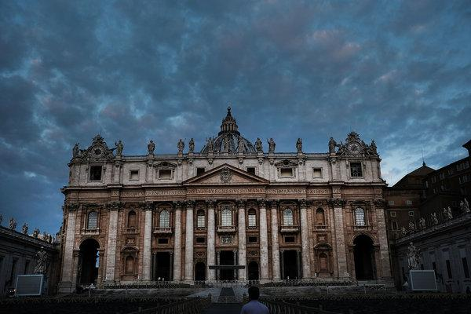
The Vatican has confirmed that it has general guidelines for clerics who father children, pressuring them to prioritize the welfare of the child and leave the priesthood.CreditSpencer Platt/Getty Images
The children are sometimes the result of affairs involving priests and laywomen or nuns — others of abuse or rape. There are some, exceedingly rare, high-profile cases, but the overwhelming majority remain out of the public eye.
The tradition of celibacy among Roman Catholic clergy was broadly codified in the 12th century, but not necessarily adhered to, even in the highest places. Rodrigo Borgia, while a priest, had four children with his mistress before he became Pope Alexander VI, an excess that helped spur Martin Luther’s Protestant Reformation. Luther wrote mockingly that the pope had as much command over celibacy as “the natural movement of the bowels.”
There are no estimates of how many such children exist. But Mr. Doyle said his support group website, Coping International, has 50,000 users in 175 countries.
He said he was first shown the Vatican guidelines in October 2017 by Archbishop Ivan Jurkovic, the Vatican’s envoy to the United Nations in Geneva.
“You’re actually called ‘children of the ordained,’” Mr. Doyle recalled Archbishop Jurkovic having said. “I was shocked they had a term for it.”
Archbishop Jurkovic declined a request for an interview.
Mr. Gisotti, the Vatican spokesman, said that the internal 2017 document synthesized a decade’s worth of procedures, and that its “fundamental principle” was the “protection of the child.” He said the guideline “requests” that the father leave the priesthood to “assume his responsibilities as a parent by devoting himself exclusively to the child.”
But another Vatican official said that the “request” was a mere formality. Monsignor Andrea Ripa, the under secretary in the Congregation for the Clergy, which oversees more than 400,000 priests, said in a brief interview that “it is impossible to impose” the dismissal of the priest, and that it “can only be asked” for by the priest.
But he added that the failure to ask to be relieved of priestly obligations was reason for the church to take action: “If you don’t ask, you will be dismissed.”
The Irish bishops have their own guidelines, and made them public in 2017. Mr. Doyle, who once studied for the priesthood and has sought to cooperate with church leaders, played a role in developing them, said Martin Long, a spokesman for the Irish Bishops’ Conference.
The Irish church’s principles do not explicitly require clerics to leave the priesthood but state: “A priest as any new father, should face up to his responsibilities — personal, legal, moral and financial.”
Pope Francis’ remarks on the issue are limited. In his 2010 book, “On Heaven and Earth,” which he co-wrote when he was the archbishop of Buenos Aires, Francis argues that a priest who in a moment of passion violates a vow of celibacy could potentially stay in the ministry, but one who fathers a child could not.

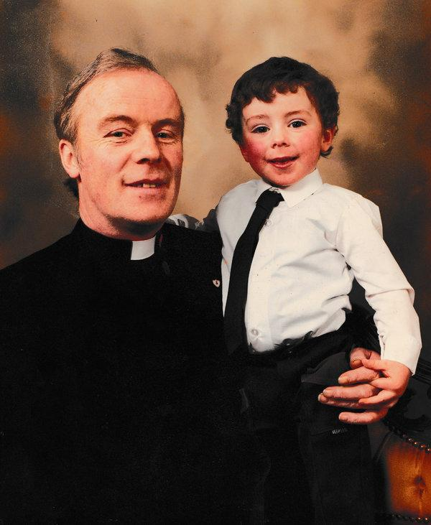
An image provided by Vincent Doyle, showing him with his biological father, Rev. John J. Doyle, in Longford, Ireland, in 1986.
“Natural law comes before his right as a priest,” he writes, adding that a priest’s first responsibility would be to his child, and that “he must leave his priestly ministry and take care of his child.”
Canon lawyers say that there is nothing in church law that forces priests to leave the priesthood for fathering children. “There is zero, zero, zero,” on the matter, said Laura Sgro, a canon lawyer in Rome. “As it is not a canonical crime, there are no grounds for dismissal.”
Mr. Doyle, along with some other children of priests and some former priests themselves, say they do not believe that dismissal from the priesthood is always in the child’s best interests, and that sometimes it potentially deprives a family of a livelihood.
“I don’t believe unemployment is a response to paternity,” Mr. Doyle said.
Some children of priests, however, wish their fathers were forced out of the ministry.
Rev. Pietro Tosi was 54 when he raped Erik Zattoni’s mother, who was 14, Mr. Zattoni said. Her family tried to force the priest to recognize their son, but he refused. The family was evicted from their parish-owned home in a tiny town outside Ferrara, Italy, where they often bumped into each other.
“He never said anything,” said Mr. Zattoni, now 37.
In 2010, Mr. Zattoni sued Father Tosi, demanding to be recognized. A court-ordered DNA test demonstrated that he was in fact the priest’s son. The Vatican eventually instructed Father Tosi’s bishop to admonish him and remind him of his responsibilities as a father, but did not demand his removal from the priesthood.
After a national news program highlighted his case, hundreds of Italians filled a Ferrara piazza in 2013 to show support for Mr. Zattoni and press Francis to take up his case.
Father Tosi died in 2014, still a priest.
“The justice I got,” Mr. Zattoni said, “came through a court sentence based on DNA.”
The children of priests are increasingly turning to DNA tests to prove that their parents are either priests or nuns.
“It’s a breakthrough, and anybody can do it,” said Linda Lawless, 56, an amateur genealogist in Australia, and herself the daughter of a priest, who has helped members of Coping International.
Her mother kept her paternity secret, but Ms. Lawless remembered noticing as a child that her mother was “absolutely terrified” whenever priests visited the house. Last year, she used a DNA test and the increasingly comprehensive databases and family trees of the genealogical website Ancestry.com to confirm that her biological father was a priest.
“That’s when the secret came out,” she said.

