Amid chaos and defiance, Venezuelan opposition faces off against security forces as Maduro digs in

Anthony Faiola and
Dylan Baddour
February 23 at 6:27 PM
SAN ANTONIO, Venezuela — A massive effort to break President Nicolás Maduro’s blockade of humanitarian aid descended into violence and chaos Saturday across the string of border flash points — showing both the growing defiance of Juan Guaidó and the U.S.-backed opposition but also Maduro’s willingness to fight back.
In a day of fast-moving developments at various points, anti-Maduro crowds at a Colombian border town faced tear gas fired by Venezuelan units, cheered as dozens of Venezuelan security forces switched sides and tried to rescue desperately needed aid packages from burning trucks.
In all, 285 people were injured and 37 hospitalized on the Colombian side of the border, according to Colombia’s foreign minister. At least four were killed on the Venezuela-Brazil border after clashing with pro-government militias.
In the Venezuelan capital, Caracas, the embattled Maduro danced at a pro-government rally, mocked the United States and broke off ties with neighboring Colombia. Late in the day, Venezuelan navy vessels threatened to open fire on a ship carrying 200 tons of aid from Puerto Rico, Ricardo Rosselló, governor of Puerto Rico, said in a statement. He said he had ordered the vessels to abandon the area temporarily, decrying the threat as “unacceptable.”
Yet in a way, this day was meant to be as much about provocation as about the aid itself. “I ask for your trust, I ask to move forward, we will keep mobilizing to end tyranny,” Guaidó told reporters late Saturday. “We have said it, change is irreversible in Venezuela.”
In a tweet late Saturday, Guaidó suggested that he would entertain more radical solutions to try to oust Maduro, a reference taken by observers to mean that he may broach the subject of additional steps by the United States, which has already imposed deep sanctions on Venezuela. The Trump administration has also repeatedly said that a military option in Venezuela is not off the table.
“Today’s events force me to make a decision: to pose to the international community in a formal way that we must have all options open to achieve the liberation of this country that is fighting and will continue to fight,” Guaidó tweeted.
He also said he would meet on Monday with the opposition’s allies, referencing a meeting that Vice President Pence was also set to attend. Pence is expected to meet with Guaidó, a U.S. official said.
The attempt to move humanitarian aid into Venezuela, opposition leaders hoped, would prompt members of the Venezuelan armed forces to defy Maduro by refusing to carry out orders to block delivery of aid to fellow countrymen in desperate need of food and medicine. The plan worked, to a degree: Roughly 60 members of Maduro’s military and security forces abandoned posts, denounced him and sought refuge with the opposition on Colombian soil.
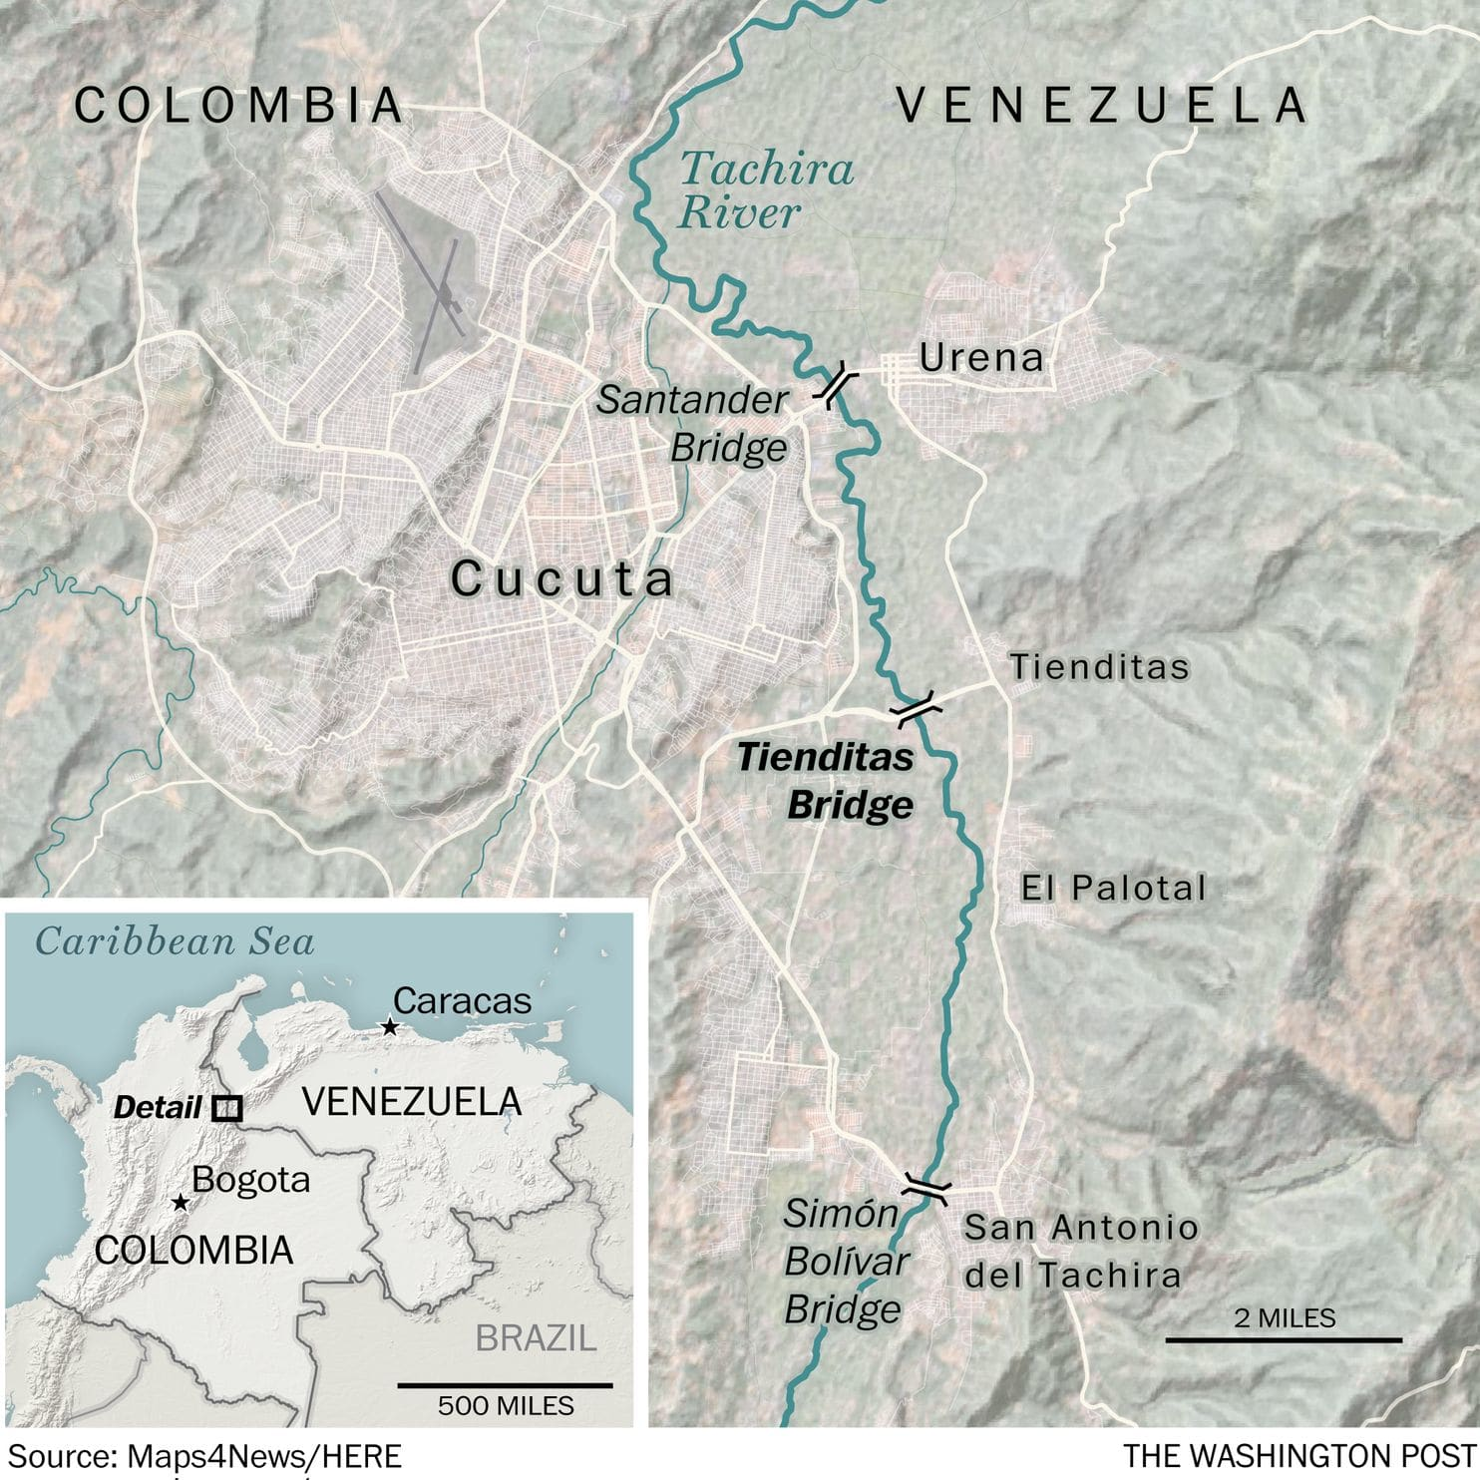
But as night fell, there was no massive shipment of food and medicine headed to Venezuela’s neediest. One truckload of aid made its way into Venezuela from Brazil and several others inched across the Colombian border into Venezuela before being blocked by government forces. And there was no political resolution, with two men — Maduro and Guaidó — still claiming the presidential mantle.
The chaos was evident throughout towns on both sides of the border.
In San Antonio, just across the Simón Bolívar Bridge from Colombia, tear gas billowed and protesters responded by throwing rocks at Venezuelan forces. Then a warning cry went up: “Colectivos! Colectivos!” — the name for pro-Maduro vigilantes.
Suddenly, a group of 20 large men on motorbikes, their faces partially covered by black masks, roared into the road. They were members of the feared pro-government militias, frequently deployed by Maduro’s loyalists, and who were widely blamed by the opposition for unleashing a torrent of fear at multiple border points on Saturday.
Protesters, aid workers, volunteers and journalists began running for shelter, dashing into buildings and cars and boarding motorcycles in an attempt to escape, as the militia members opened fire.
“It was horrifying, horrifying,” said opposition politician Carlos Valero, who was present for the San Antonio attacks. “The last thing we imagined was that Nicolás Maduro was going to put out so many irregular forces. They shot at us, and the national guards threw tear gas. We didn’t expect that level of irrationality in response to humanitarian aid.”
The events spiraled close to the realm of international conflict. On the Simón Bolívar Bridge, tear gas volleys and rocks flew from both the Venezuelan and Colombian sides, with Colombian authorities arresting at least two irregular Venezuelan militiamen on the Colombian side of the border.
“#MaduroRegime has fired into territory of #Colombia,” Sen. Marco Rubio (R-Fla.), who has closely advised President Trump on Venezuela, tweeted on Saturday. “Receiving reports of injuries after this attack on sovereign Colombian territory. The United States WILL help Colombia confront any aggression against them.”
National security adviser John Bolton tweeted that Maduro’s response to trucks of humanitarian aid had been “masked thugs, civilians killed by live rounds, and the burning of trucks carrying badly-needed food and medicine.” He suggested that more sanctions were coming.
Pence, who will go to Colombia on Monday to give a speech reiterating U.S. support for Guaidó, also took to Twitter to show solidarity with the opposition: “Estamos con ustedes. We are with you.”
Guaidó, the opposition leader, began the day Saturday by tweeting, almost optimistically, about the mission at hand.
“Venezuela, the day has arrived in which we will take the step to enter humanitarian aid. From our borders, by land and sea, we will bring hope, food and medicines for the ones who need it the most,” he wrote. “We call everyone to go out massively to the streets in the whole country, to protest in peace at barracks, to urge the armed forces to let humanitarian aid in.”
Yet after an attack by the Venezuelan military near the Brazilian border that left two civilians dead and 11 wounded on Friday, fears mounted that the attempt to move aid into Venezuela could be marred by further violence. By Saturday morning, the Venezuelan government had temporarily closed three key border crossings with Colombia. Just before the 8 a.m. start time for the effort to try to break the blockade, a violent confrontation broke out on the Santander bridge in the western border town in Ureña — one of the crossings to Colombia ordered closed by the Maduro government.
On the Colombian side of the border near Cúcuta, the day got off to a promising start for the opposition when defectors from Maduro’s armed forces rammed a barricade installed to stop aid from getting through, then turned themselves over to Colombian authorities.
In a dramatic moment, opposition leader Jose Manuel Olivares led a throng of volunteers halfway across the Simón Bolívar bridge linking Colombia and Venezuela, prompting a rank of Venezuelan border guards to line up with riot shields. Through a bullhorn, he addressed the Venezuelan guards.
“I tell you my brothers, stand by the constitution and on the right side of history!” Olivares shouted. “I ask you to end this blockade, and let aid in. I bless you, and hope we hug when we pass.”
Soon after, though, a Venezuelan column with riot gear blocked the bridge. As protesters sought to pass anyway, the Venezuelan side began intense volleys of tear gas that sent protesters in a stampeding retreat down the bridge that left several people injured.
Then came the buzz of rubber bullets. Later, protesters who’d gone under the bridge to hurl rocks came running back out, saying colectivos and Venezuelan border guards had opened fire on them from the other side of the border. At least two young men came from under the bridge with gaping wounds.
Dozens of tear gas canisters were lobbed well across the river dividing the two countries, prompting crowds and police to fall back deeper into Colombia. Volleys of tear gas also came from the Colombian side, though it was not clear who was firing.
Beneath the bridge, dozens of young men gathered around a Colombian soldier who asked if it was true that Venezuelan guards beneath the bridge were firing weapons.
“They are there, I saw them,” said Leonard Castillo, 19. “They shot my friend in the eye.”
About 20 members of the Venezuelan guard defected and turned themselves in at the bridge, presenting themselves to a crowd that sometimes beat them before Colombian police intervened. Authorities reported that 60 members of the guard turned themselves in Saturday across all of the Colombian border.
As night fell, hundreds of people remained under and on the bridge, throwing stones and occasional fire bombs. The tear gas and smoke from a brush fire under the bridge formed a thick curtain over the Venezuelan side as protesters and organizers here attempt to regroup, clearly in lower spirits than several hours ago
Although organizers initially said they would create a human chain to hand boxes of humanitarian aid person to person across the bridge, the trucks were never unloaded. They fled the Bolívar bridge in the midafternoon as it became clear the Venezuelan guards would not yield.
As he gathered rocks to throw at the loyalists from under the bridge, a young opposition protester, Oscar Arcilla, 19, said “the war has begun.”

