Tales from the Hive

Communication
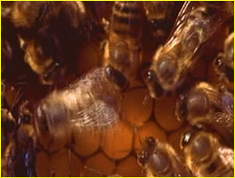A worker does the waggle dance before an attentive crowd of foragers.

Honeybees have evolved an extraordinary form of communication known as the "waggle" dance. It is highly symbolic, separated as it is in both time and space from the activity it grew out of (discovering a nectar source) and the activity it will spur on (getting other bees to go to that nectar source).
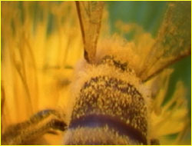When a worker discovers a good source of nectar or pollen (note the pollen spores dusting this bee's back), she will return to the hive to perform a waggle dance to let her nest mates know where it lies.

A bee performs the waggle dance when she wants to inform other bees of a nectar source she has found. The waggle occurs on a special dance floor, which is conveniently located near the entrance to facilitate quick entry and exit of foragers, and only bees with news of highly profitable sources of nectar execute the dance. Arriving back at the nest, a bee with news to share immediately proceeds to the dance floor, where other bees waiting for news gather around her. During the waggle, she dances a figure-eight pattern, with a straight "walk" in between the loops and a sporadic fluttering of her wings.
The worker communicates several key pieces of information during the dance. The longer she waggles - typically bees make between one and 100 waggle runs per dance - the farther the flower patch lies from the hive, with every 75 milliseconds she prolongs the dance adding roughly another 330 feet to the distance. She shows how rich the source is by how long and/or how vigorously she dances. Perhaps most astonishingly, she indicates the direction of the source by the angle her waggle walk deviates from an imaginary straight line drawn from the dance floor to the sun at its current position. In other words, if the source lies in the exact direction of the sun, the bee will walk facing exactly straight up (remember that a hive hangs vertically). If it lies 20 degrees to the right of that imaginary line to the sun, the angle of the bee's walk will be 20 degrees to the right of vertical. Finally, the dancer shares the odor of the flowers in question with the other bees, who sample it with their antennae.
Attendees will watch only one waggle dance and only for a brief period before leaving the hive. In this way, the bee works for the good of the hive rather than for the good of herself. If she stayed for the whole dance, she would know exactly how rich the source is, for instance. But if all bees waited for the entire dance to take place, and then only went to the richest sources, the colony would not be maximizing its use of available resources. This behavior is one of many instances of how, when it comes to honeybees, natural selection operates on the level of the colony, not the individual bee.
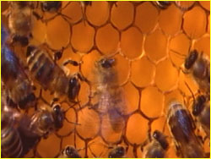With the waggle dance, a worker communicates the distance, direction, and quality of a nectar-rich flower patch to her fellow honeybees.

Honeybees perform two other types of dance. A worker does the "shake" dance when nectar sources are so rich that more foragers are needed. A worker arriving back from a foraging run will move throughout the hive and shake her abdomen back and forth before a non-foraging worker for one to two seconds before moving onto more non-foragers at the rate of between one and 20 bees per minute. The shake dance encourages these non-foragers to make their way to the waggle dance floor.
Finally, workers do the "tremble" dance when foragers have brought so much nectar back to the hive that more bees are needed to process the nectar into honey. Walking slowly around the nest, the dancer quivers her legs, causing her body to tremble forward and backward and from side to side. Lasting sometimes more than an hour, the tremble dance stimulates additional bees to begin processing nectar.

