Snoop Dogg’s Most Impressive Act Might Be In Youth Football
Martin Rickman
Managing Editor, Sports + DIME
04.20.18
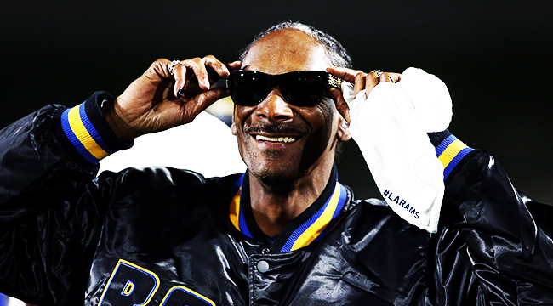
Getty Image
TORRANCE, Calif. – With 32 teams from across the nation competing at the adidas Football 7 on 7 Championship, things were bound to get chippy sooner or later. On Sunday, as the bracket tightened and players fought to make an impact and get one final set of eyes from scouting services on them, the games themselves got even more competitive. A matchup between Team Natty and Team Phase 1 was no different.
There’s plenty of trash talking in 7 on 7, but most incidents are kept to the sidelines, as players continue jawing after the whistle at each other. Shoves do happen every now and then, and a scuffle between Team Natty and Team Phase led to two players having to be broken up. A coach walked across the field to speak to one of the two instigators, whispering words as the wide receiver nodded. The coach then went back to the other end of the field to talk to the defensive back, putting his arm around the high schooler to resolve the situation.
This isn’t out of the ordinary for a coach to take time and calm things down. Although it might seem out of the ordinary to see who that coach was. For the better part of two decades Snoop Dogg has devoted a big part of his life to youth football, and the platinum-selling recording artist, actor, and entrepreneur seems to be always coaching now, even when he isn’t. (He even was a player coach in a West Coast vs. East Coast rap pickup game during NBA All-Star Weekend at the adidas 747 Warehouse installation.)
Kids come up to him constantly, asking for selfies or a shoutout on IG, and he’s quick with a dap or a kind word. Parents are excited to see the rapper from the L.B.C.; their kids are hype to see Coach Snoop. This is the next chapter for the Doggfather, and one where he can impact young lives daily.
UPROXX got the chance to speak with Snoop about his love for coaching, his relationship to football, how Luther Campbell from 2 Live Crew helped pave the way for him to get into coaching, and more.
Martin Rickman: You got the chance to talk to the two guys that scuffled a little bit in the end zone a little bit ago, I mean coaching is your life now huh?
Snoop Dogg: Yeah, I mean it’s been my life for the past 15 years. This is what I do.
What’s the biggest thing you’ve learned about yourself through coaching?
Just being able to see certain things. As a coach, you have to have awareness to see certain things before they happen and be able to recognize whether it’s schematically as far as putting plays together, or you see an altercation happening. You gotta be on top of your p’s and q’s as a coach to make sure everything flows the way it’s supposed to.
Who do you look to coaching-wise that have been inspirations to you?
Probably my coach that I had when I was a kid. Coach Neely, Herschel Neely, was one of my greatest coaches I ever had as a kid. And I just like watching coaches. I like a lot of coaches that are in the NFL. The big name coaches, Pete Carroll, Belichick, Mike Tomlin. Great coaches like John Madden. Great coaches from back in the day. The way that they coached. They coached with a different type of attitude and their players played for them and they was up close and personal with their players. It wasn’t like the coach wasn’t your friend. Your coach was your friend and you played for him because you wanted him to succeed and didn’t want him to get fired. So it’s like those are the kind of coaches that I looked up to, that had players that played for them.
In your league you get that chance to be up close and personal with guys. Really impact them at a time when they’re really, they’re impressionable. Anything that they can have, five minutes, a hour, two hours, that can be so critical for them in that time where their brains are growing and things really are important to them.
It is. That’s why it’s important to put the right things in their head. Because it becomes muscle memory. And whatever they doing is going to become a part of their life if they doing it over and over repetition. If you putting the right things in their head, teaching them the right way and letting them know that when you do make a mistake it’s okay. Just fix it and try to do better.
You get the chance when you come out to events like this, everyone comes over to you. They want to be around you. To have that impact all these years later after everything that you’ve done, what does that mean to you?
It just means that I’m doing my job off the field. My rap career is on the field. But what I do off the field matters more. because it ain’t about my music. Those kids don’t care nothing about my music. Not one of them asked me about a song, video, and all that. They care about Coach Snoop being up close and personal. And I share that moment with them. They know I know football. They know I love football. They know I coach. And they know they can take a picture with somebody who understands what they going through. And could possibly be a mentor to them or even just a friend.
I know you’ve had little friendly wagers and experiences with Uncle Luke too. When he and I have talked about that over the years, that’s been so important to him is getting with those kids. They don’t know 2 Live Crew, that’s generations ago now, what he’s known for, for people that grew up around him. But now it’s a whole new ballgame.
It is but when we do it, we don’t do it for fame. We don’t do it for notoriety. We do it because we love the kids and we love our communities. And then as time goes on, you look up it’s 15, 20 years later and we’re still doing it. And people finally recognizing what we doing. Luke is the creator of what I’m doing. He was doing this 10 years before I even got started. He’s somebody that I look up to as a coach. He’s somebody that I aspire to be because he went in the depths of Miami, in the worst parts and he helped kids out, get out, go to high school, go to college, and then go to the NFL. That’s what I aspire to be. To do something like he did off the field, because his records was great. 2 Live Crew was the sh*t, but what he does for those kids and their lives means way more than what he done in the music world.
The show obviously you had the chance to see it now and watch what came out of it, what was your impression of that afterward and is there gonna be a followup?
It was my last year coaching. That was the beauty of it all. But that’s like the sad part of it all. You won’t see me coaching again. But we’re working on a movie right now the making of the SYFL. That should be an original Netflix movie which will show the beginning of the SYFL The first group of kids I coached. The path that we went on. How long we been in existence. The Super Bowl players. The kids that we lost. The kids that we saved. So we gonna be able to put that together and be on the lookout for that next year.
I just moved to Long Beach recently. Where should I go eat?
Roscoe’s. Right over the Palm Gardens. Pull up there at Roscoe’s and get you some. Or M & M Soul Food. Pee & Gee Fish Market closed down, but they got a Louisiana Chicken in North Long Beach. But you just come on down. Louisiana Chicken is the bang, man.

